***Experiment No.02***

***Experiment Name:***

Use Of some basic command in linux terminal.

***Aim and goals:***

* We can use the terminal for doing the other important things easily.
* We can now read,write even can make file in any directory by using The terminal.
* We can get greater control over system functions.
* We can learn faster and smarter way of doing just about everything.

***Use of few basic Command in Linux terminal:***

1.To show all thing in a particular place Linux use “ls” command.

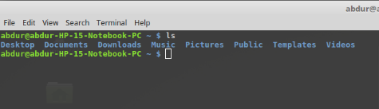

2. To change the directory Linux use “cd dir_name” command.

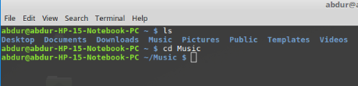

3. To make a directory Linux use “mkdir directory_names” command.

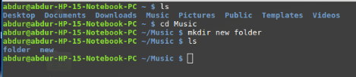

4. To delete a directory Linux use “rm -r directory_name” command.

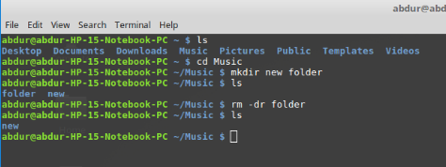

5. To show the path of current place Linux use “pwd” command.

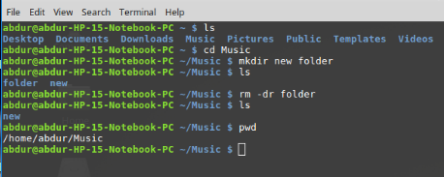

6. To create a file Linux use ”touch file_name” command.

& To read from a file Linux use “head file_name” command.

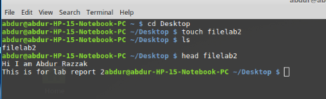

Conclusion:

In this lab we successfully learnt few basic and important command of linux in Terminal.Using This terminal now we easily can go to any directory,make file,read and write to a file ,delete a file and something more.Our Respected Course teacher Nazrul sir helped us for going through successfully.